## What Is JIRA?

JIRA is a [project management software](https://www.simplilearn.com/best-project-management-software-for-teams-article) developed by the Australian company Atlassian. The word JIRA is derived from the Japanese word ‘Gojira’, meaning Godzilla. The software is based on agile methodology. If you’re wondering what is jira used for, the answer is multiple purposes – bug tracking, issue tracking, and project management. Many businesses also use JIRA software in non-standard ways as warehouse automation tool, document flow, expenses optimization, and others. The JIRA dashboard contains several useful functions and features which enable easy handling of issues. One of the most sought after agile project management solutions, JIRA has recently tweaked some of its products for all kinds of teams and organizations including IT, marketing, operations, finance, HR, legal and other departments.

## Different Uses of Jira

Originally designed as a bug and issue tracker, Jira serves as a powerful work management tool for various use cases like:

* Requirement and Test case Management – to manage manual and automated tests
* Agile Teams – JIRA software provides scrum and Kanban boards for teams practicing agile methodologies.
* Project Management – JIRA software can be configured to fit any type of project right from onset, through execution, to wrap up.
* Software Development – for developing better software, faster by incorporating Atlassian tools.
* DevOps – Atlassian open DevOps helps teams ship better software, stressing on best practices.
* Product Management – JIRA help design detailed roadmaps, handle dependencies, and share plans and progresses.
* Task Management –JIRA makes it easy to create tasks to work on, with details, due dates and reminders.
* Bug Tracking – the powerful jira workflow engine makes sure that bugs, once captured are automatically assigned and prioritized.

Scrum:

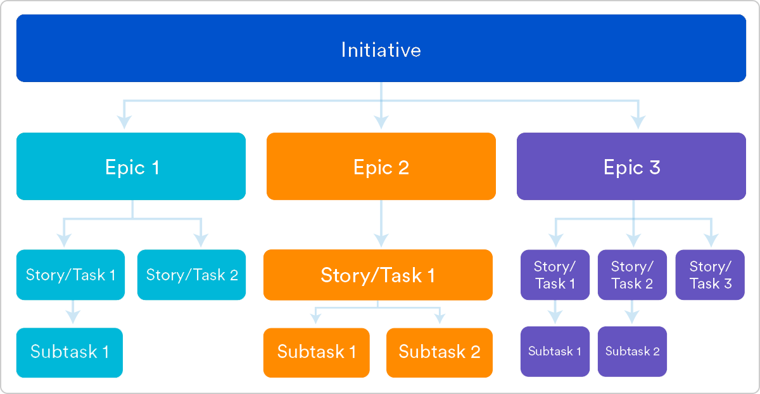

Epic:

An epic is a large body of work that can be broken down into a number of smaller [stories](https://www.atlassian.com/agile/project-management/user-stories), or sometimes called “Issues” in Jira. Epics often encompass multiple teams, on multiple projects, and can even be tracked on multiple boards.

Epics are almost always delivered over a set of sprints.

User story:

A user story is the smallest unit of work in an agile framework. It’s an end goal, not a feature, expressed from the software user’s perspective.

A user story is an informal, general explanation of a software feature written from the perspective of the end user or customer.

The purpose of a user story is to articulate how a piece of work will deliver a particular value back to the customer.

Story Points:

Story points are units of measurement used in agile project management to gauge how much effort is required to complete a user story from the product backlog. Scrum teams often use them in [sprint planning](https://www.7pace.com/blog/sprint-planning-for-software-teams) sessions to determine the amount of work they can complete within a specific time frame.

Most teams use the Fibonacci sequence to represent agile story points. Many simplify the numbers to “1, 2, 3, 5, 8, 13, 20, 40, and 100.”

The spacing between the numbers becomes further apart as the story point values get higher. It gives development teams more wiggle room to accommodate uncertainties, which tend to increase when the scope becomes larger.

